**DEPARTMENT OF INFORMATION TECHNOLOGY**

**Course: DSA Lab( ITL302)**

**B.Tech. (Information Technology) – Semester III**

**Academic Year: 2024-25 (Odd Semester)**

**Experiment No: 6**

**Aim:** Implementation of Binary Tree and its Traversal for real-world application.

**Code:** 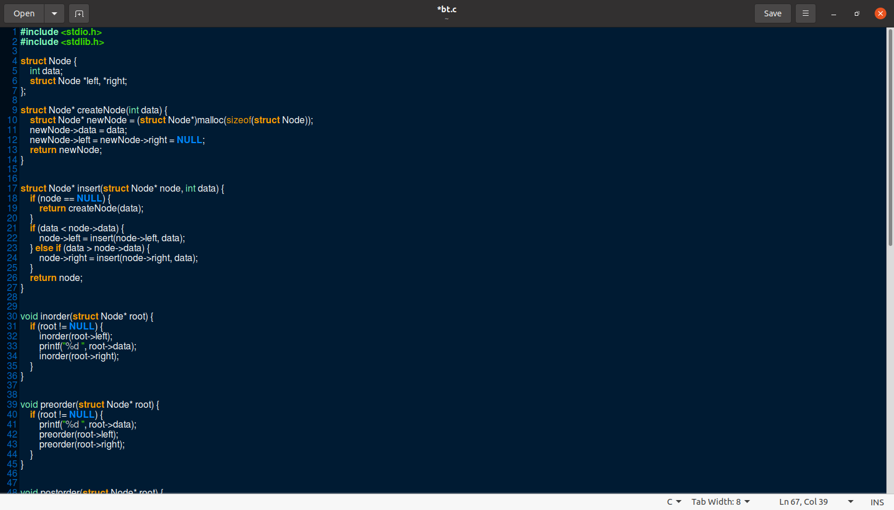

**Output:**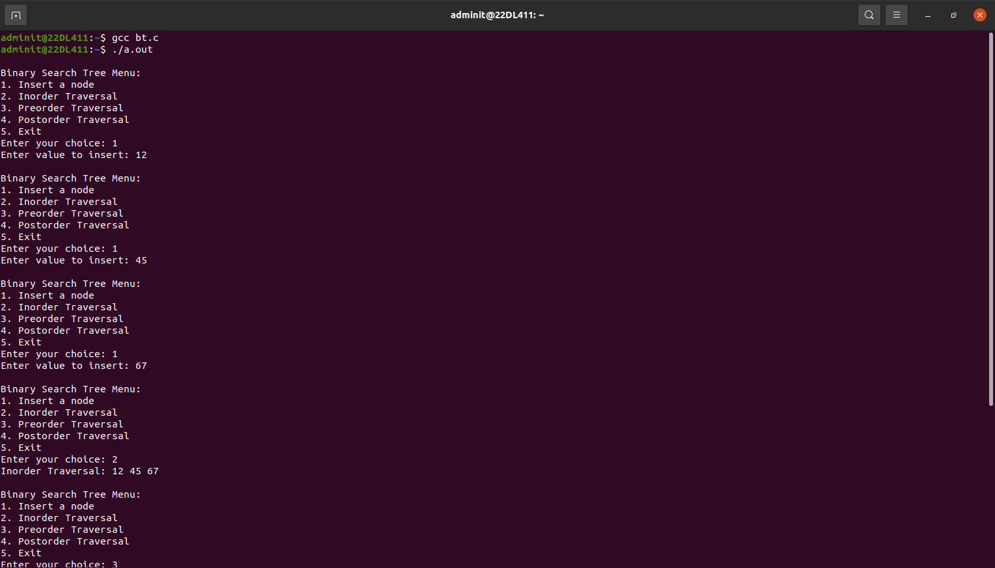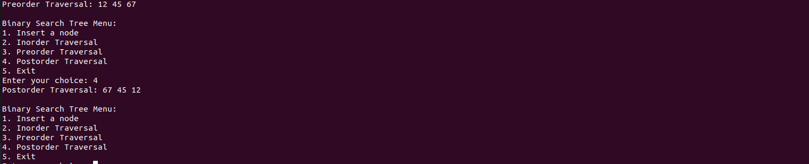

**Submitter Details -**

**Name of Student:** Subroto Datta

**Roll No.:** 17

**Date of Performance:** 20/09/2024

**Date of Submission:** 20/092024